
St Martins School | Te Kura o Hato Mātene
Newsletter 8 : Thursday 6 June 2024

SCHOOL UPDATE
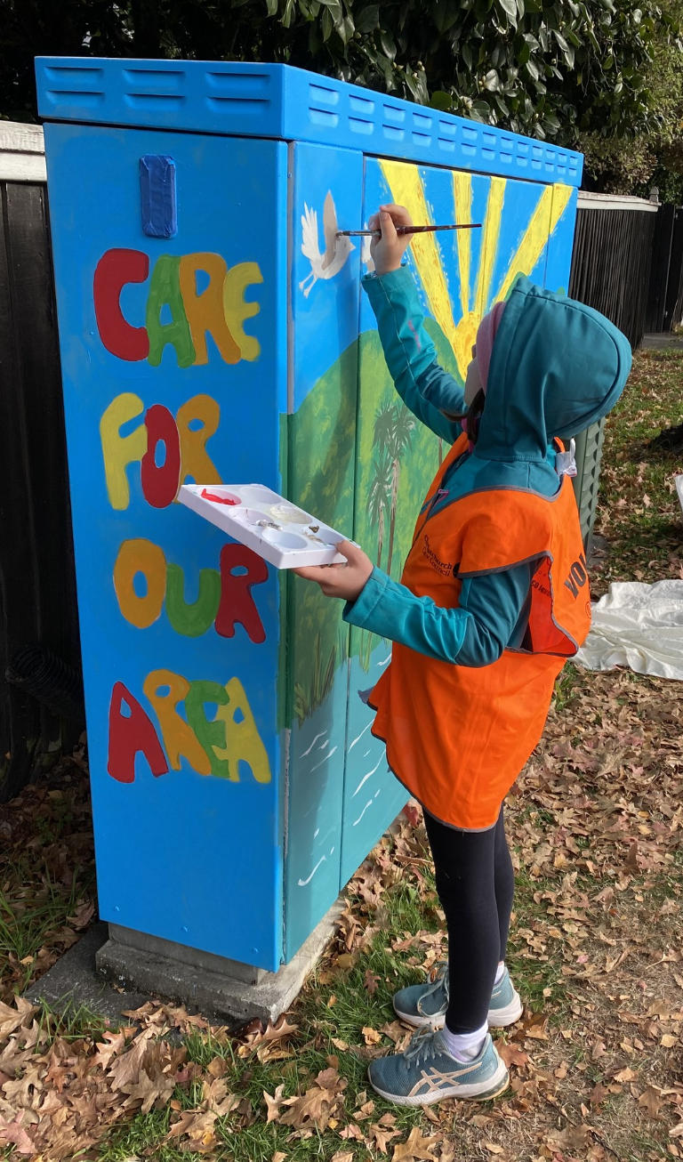
We had an enjoyable staff only day last week with the kaiako | teachers from the cluster of schools we work with. There were lots of positive messages that we have taken away to continue to discuss and implement in our daily practice. A number of these are based around supporting self regulation. A catch phrase to hold onto may be, only a clam brain can calm a brain. Thank you for supporting us with our staff only day, we hope you were able to have a relaxed long weekend.
Last week I was really impressed with the netball teams I watched at the Hagley competition. Lots of support and encouragement for each other and respect for the opposition. We continue to grow our gratitude with a requirement of the captains to take the initiative to shake hands and thank the referee and the opposition coach. It’s great to see this starting to become common practice for our kura.
We welcome Otis to our New Entrant space at St Martins | Hato Mātene, we hope you enjoy your experiences at our school, we look forward to sharing in your learning journey.
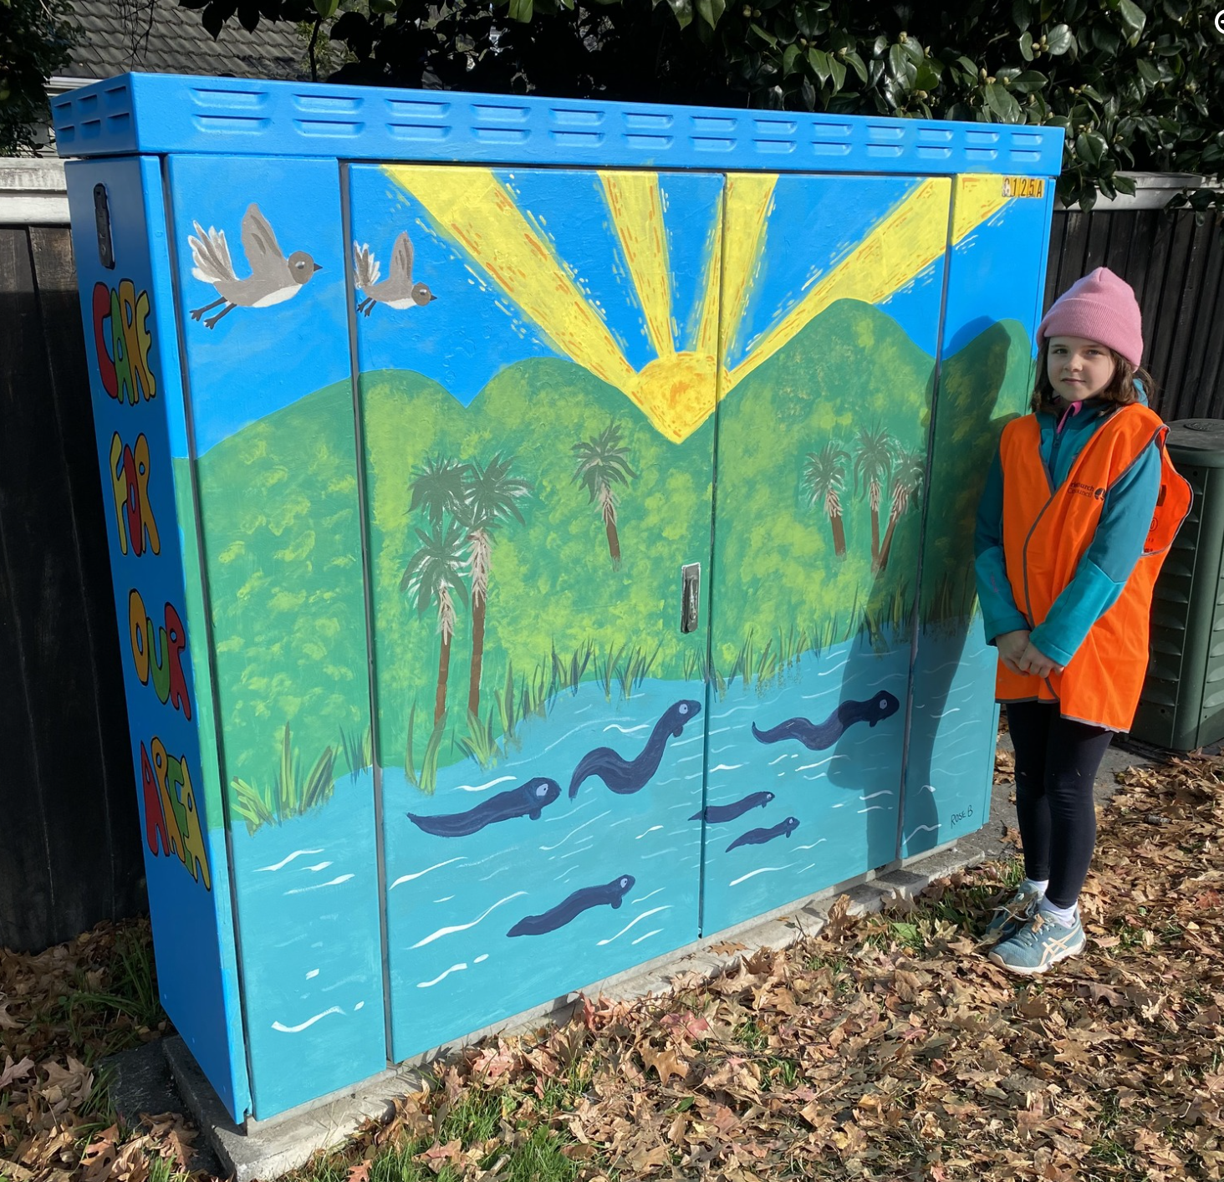
The nursery team of 40 tamariki are working with Mrs Susie Keenan, currently looking after plants through the winter for planting in the red zone later this year. We continue to look for opportunities to be involved and support the wider community.
The Y3 - 5 strum, strike, blow group of approximately 35 children led by Miss Paige Hampton and Mrs Jenny Oldridge is in full swing. Our group will join over 50 schools participating this year on Thursday August 15th, 2024. It is always great to have the chance to share in large performance groups.

The Y8 tamariki received their leavers hoodies last week. These look cosy and warm for the wintery mornings we are having.
Congratulations to Rose who was one of the winners of the "What's Cool About Your School / Community" cabinet competition run by the CCC Graffiti Programme. Ākonga from SMS | HM were invited by the council to share what they loved about our community. Rose's design was chosen for its environmental message and clear connection to our local environment. Rose spent her long weekend drafting and painting her incredible design onto a cabinet on Centaurus Road. It looks amazing, Mahi Nui Rose on your beautiful artwork.
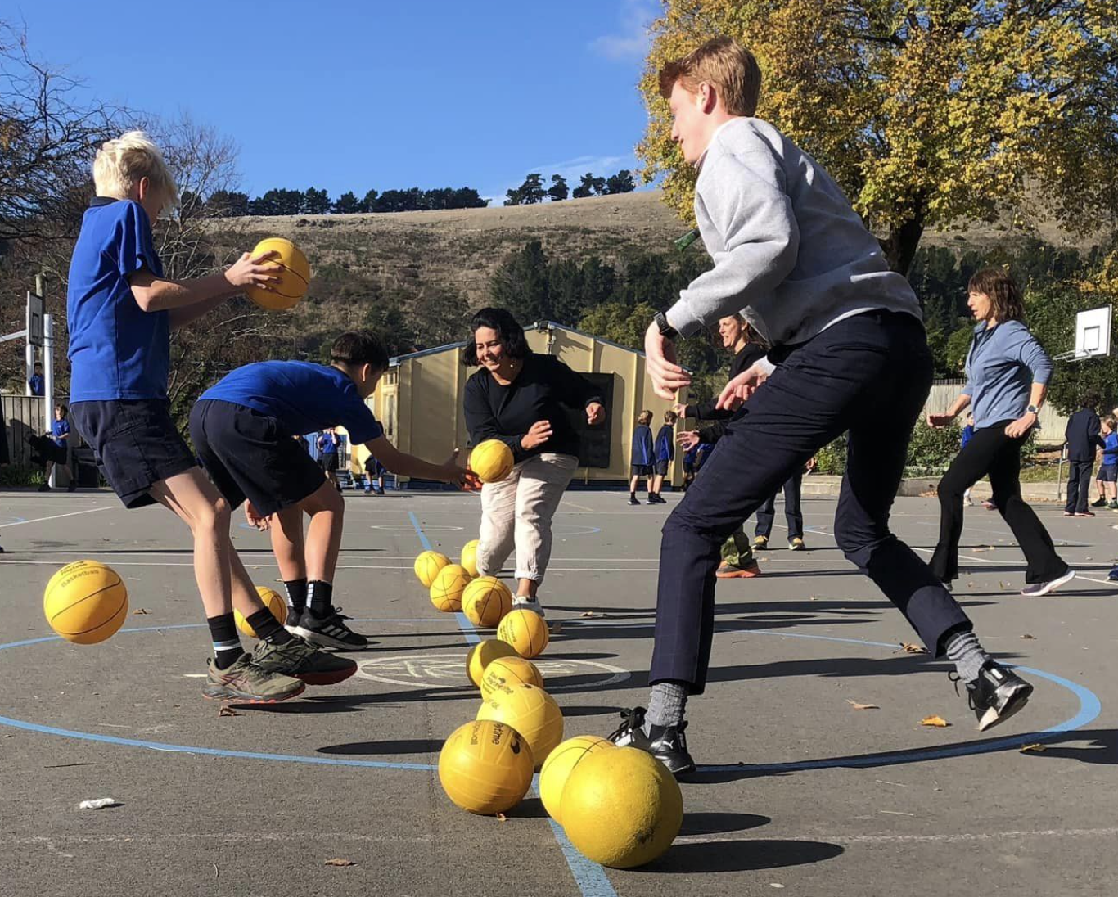
Last week the Y8 leaders organised a students vs staff dodgeball competition. Both teams gave their all on the court with a one on one between Rory and Mr Jarad Pateman ending in a 1 all deadlock. As always it’s great to get involved in these challenges, next up is the Lip Sync providing opportunities for children across the school to participate.

STAFFING
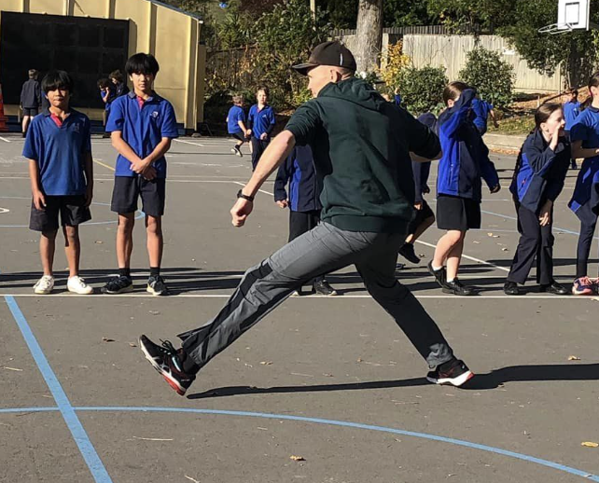
At the end of the term we will be farewelling Mrs Alice Robins. Alice currently teaches in the Y7 / 8 area of the school, previously she has taught in Y5 / 6 with a two term stint in the new entrant class. Alice, Aaron and Lexie will be moving further up the South Island to Nelson to join their extended families. We thank Alice for the wonderful teaching and learning experiences, environment and positive rapport she has brought to the school. Alice will be teaching for the remainder of term two. We will be advertising a fixed term position for the remainder of the year. Although a loss for our school, we support Alice and her family in her move north.

REPORTING
The online report will be open on Monday 1 July. We will be holding parent learning conferences throughout that week.
We invite you to join us for some face-to-face ‘how to’ sessions for parents who would like to know more about what the online reports will look like. These will be 30 minute sessions on the following dates:
- Monday 24 June 2.30pm
- Tuesday 25 June 9.00am
- Wednesday 26 June 5.00pm
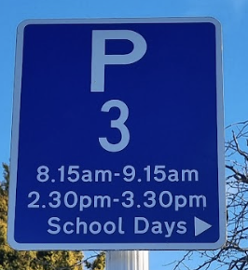
We will also be available through the learning conference week if you want to pop in. Alice Denley has put together information slides for parents to refer to in their own time as well.

PARKING
It seems we have a few continued issues parking and driving around the school. If you are dropping children off you will be aware how narrow our roads are on Albert Tce. We ask that you keep all of our tamariki safe by using the crossing and footpath and adhering to the following:
- Park in the allocated areas
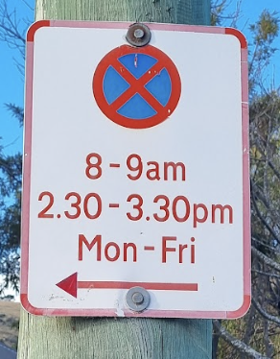
- Follow the time periods for parking
- Be aware of parking over neighbours driveways
- Watch for children if you are coming in and out of the school driveways
- Keep the flow of traffic and avoid U turns on Albert Tce near the crossing
And as always be a respectful role model for your children if a conversation arises either with a staff or whānau member.

Ka pai te wiki mutunga, have a great weekend.
Andrew

PB4L SCHOOL FOCUS - Responsibility
The Term 2 focus for Positive Behaviour for Learning (PB4L) is the school value of Responsibility.
During weeks 7-9 the focus will be on our responsible care of property. All students are being encouraged to be mindful of how they look after their and others belongings by using the following etiquette;
- Return items left outside to designated areas. (Lost property in bins or back to owner, sports gear to correct areas in sports shed, classroom items returned to correct places
- Name your own belongings and know where they are at all times
- Use school and individual belongings / equipment responsibility and for its correct use
This will be further reinforced through classroom lessons, syndicate hui’s and school assemblies. It would be great if whānau could help to support these ideas in your discussions at home.

SCHOOL POLICY - COMMUNITY REVIEW
SchoolDocs – what is it?
All NZ schools are governed by a school board and a range of policies and procedures. Our policies are hosted by SchoolDocs Ltd, an online policy and procedure service for New Zealand primary and intermediate schools.

Caregivers and parents of St Martins School have the opportunity to review and place feedback on the policies that are under review each term. Reviews for T1 must be placed by Monday 17th June

Login here and go to the ‘Current review’ tab to review the following policies;
Username: stmartins
Password: huntsbury

Community review topics for Term 2
- Equal Employment Opportunities
- Teacher Relief Cover

- Classroom Release Time / Timetable
- Police Vetting

PTA UPDATE
Bingo Night: Not long now until our main fundraiser of the year and a great night out together. What’s not to love about old school bingo with a modern twist: Number 6: Little Mix, Number 8: Tinder Date! 32: Jimmy Choo, 88: Wills and Kate. Secure your ticket/s now for next Saturday night: BINGO FORM
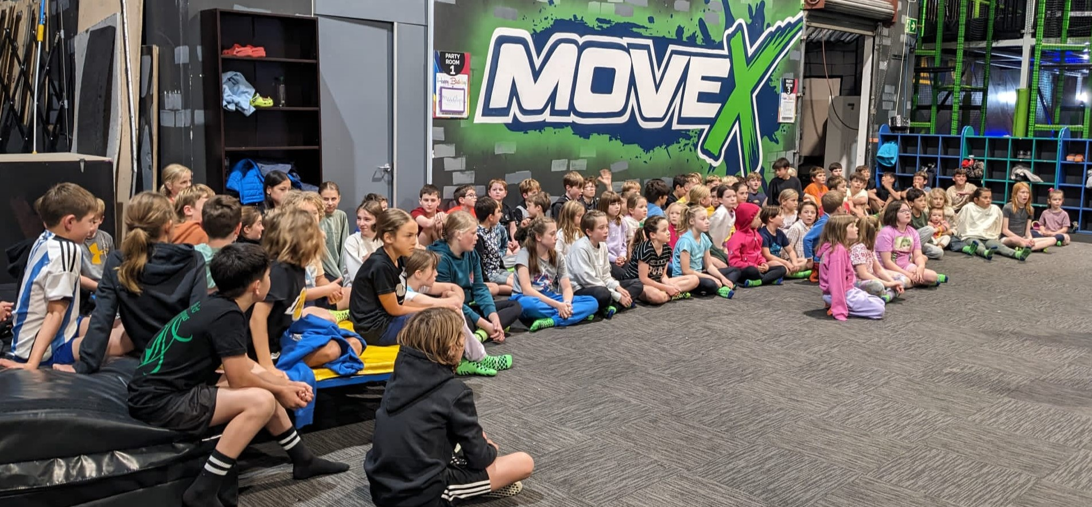
Thank you to some of our many sponsors and supporters: Pinot & Picasso, Pushbikes, Spoilt Boutique, Texture Plants, Uprising, The Old Vicarage, FurtherFaster, Kowhai Vet, He Puna Taimoana, Barker’s of Geraldine, Monstera & Men, Aromaunga Baxters Flowers, Beckford Health Pharmacy, Adrenaline Forest and Orana Wildlife Park.
Disco: The Student Council and PTA look forward to bringing you the annual school disco next term on Friday 2nd August, save the date! Junior school 5.30 – 7pm and senior school 7.30 – 9pm. We will need your support to run this popular event so please look out for the disco sign-up genius before the end of term.
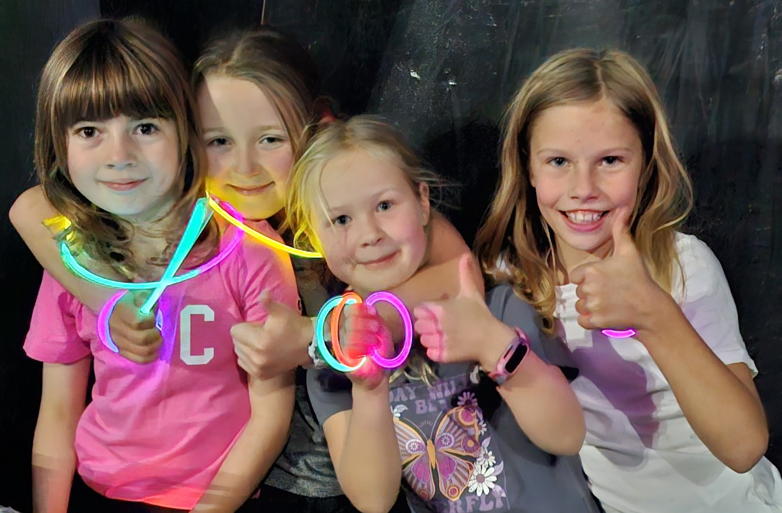
Move X: Thank you to all the children who came along to Move X for looking out for each other and enjoying a big game of build-up together across all ages. Our thanks to the parents who helped during the event.
Contact Us: info@stmartinsschoolpta.org.nz
Facebook: St Martins School PTA

Next Meeting: Monday 24th June, 7.30pm, Staff Room


WHĀNAU GROUP
Kia ora e te whānau,
A reminder of Matariki coming up in weeks 9 & 10! Keep an eye out in the school newsletter and on HERO for our events during these weeks! If you're interested in connecting with other whānau and being a part of a supportive community, come along to our hui’s.
Meetings are held at 3:30pm in Ms Barakat’s room on the top courts. Dates for Term 2, 2024: 6 June, 4 July
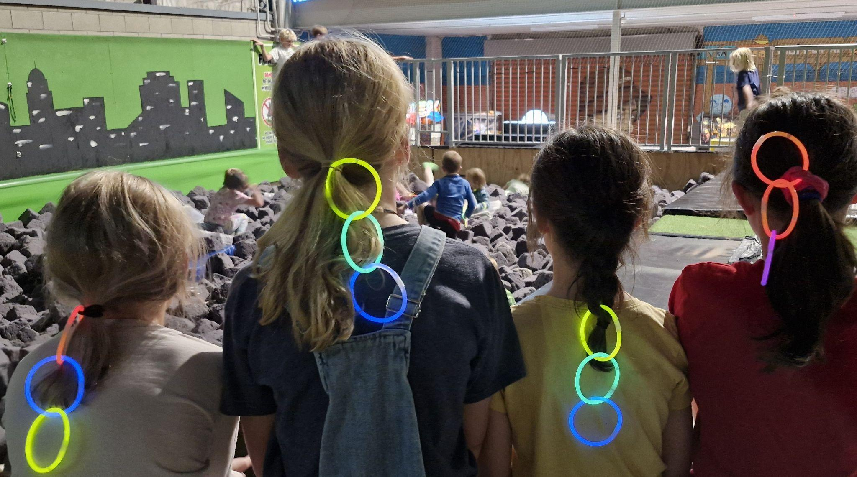
Ngā mihi
Alexis Barakat | Whānau Group contact
Email: alexisbarakat22@gmail.com

COMMUNITY NOTICES
Cashmere High School Open Day - Tuesday 11th June

Due to various clashes, Cashmere High School has changed the date of their Open day to Tuesday 11th June. The start time has also changed to 3.30pm and 4.30pm for our tours.

Health & Lifestyle Coaching
Diana Stolworthy is a school parent who offers health and lifestyle coaching and personal training from
a family owned and family friendly 190 Gallery Gyn on Montreal Street. Wallet friendly memberships starting at just $7.99pw. For more information on what we offer and how to join visit https://the-gallery-gym.co.nz/

FREE Swimming Canterbury "Have-a-Go Carnival"
Swimming Canterbury West Coast is excited to announce our second dedicated "Have-a-Go Carnival" event for 2024 on the 16th June at Taiora QEII Recreation & Sport Centre.
The event is open to any swimmer (of any age) who is not currently registered as a club or competitive swimmer with Swimming New Zealand and is capable of swimming 25m without assistance.
Swimmers are welcome to swim in 25m, 50m, kick, and relay races!
For more information on how to register head to our website event Page: wearescwc.org/have-a-go-events




TERM 2 2024
7 | Mon 10 Jun | Tues 11 Jun | Wed 12 Jun | Thur 13 Jun | Fri 14 Jun
 | Yr 7 Hearing & Vision testing | Cashmere High School Open Day | GTT  room 15 & 16 | Yr 5-8 winter sports | Year 7 & 8 Technology
8 | Mon 17 Jun | Tues 18 Jun | Wed 19 Jun | Thur 20 Jun | Fri 21 Jun
 | 0-2 Huff n Puff  11.45-12.30pm | Epo8 Internal event - hall  PP - Yr 0-2 Huff n Puff  11.45-12.30pm | Epo8 Internal event - hall  GTT  room 13 & 14 | Yr 5-8 winter sports  EPro8 internal Competition  Newsletter | Year 7 & 8 Technology  EPro8 internal Competition  SHOWQUEST  Year 7/8 spoken word finals  Assemblies  9-9.45am yr 0-4  2.15-3pm yr 5-8
9 | Mon 24 Jun | Tues 25 Jun | Wed 26 Jun | Thur 27 Jun | Fri 28 Jun
 | 9.15 Yr 5-6 Korfball lessons  PTA meeting (staffroom)  7.30-8.30pm | Matariki Art Display - hall  12.30 Yr 3-5  Kaitiaki Crew  Board meeting (staffroom) 6.30pm | GTT  room 15 & 16  12.30 Yr 3-5 Kaitiaki Crew  Canterbury X Country | Yr 5-8 winter sports | Matariki  School Closed
10 | Mon 1 Jul | Tues 2 Jul | Wed 3 Jul | Thur 4 Jul | Fri 5 Jul
 | Yr 7/8 Korfball tournament  Reports sent home via HERO  Yr 5-8 Korfball | Yr 0-4 Zone Cross Country  12.30 Yr 3-5  Kaitiaki Crew | 12.30 Yr 3-5 Kaitiaki Crew | Yr 5-8 winter sports  Newsletter  Whānau Hui 3.30pm | Year 7 & 8 Technology  Last day of term 2 - closing 12.30
 | Learning Conferences

